**Section 4.7 Position Error Test Methods**

**4.7.1 Fly-by**

As depicted below, the flyby method originally used some sort of viewing platform with surveyed distances and a grid or other device for determining the aircraft’s relative angle above the platform’s altimeter. This information combined to give the aircraft’s actual pressure altitude. Modern methods replace the tower system with a radar altimeter or GPS unit to determine tapeline height above the flyby line (*Hg*). This geometric height is converted to a pressure altitude change using a temperature correction. When added to the aircraft’s pressure altitude on the runway, this change provides the actual pressure altitude during the flyby (Actual *Hc* = runway pressure altitude + *Hg*(*Ts*/*Tt*).

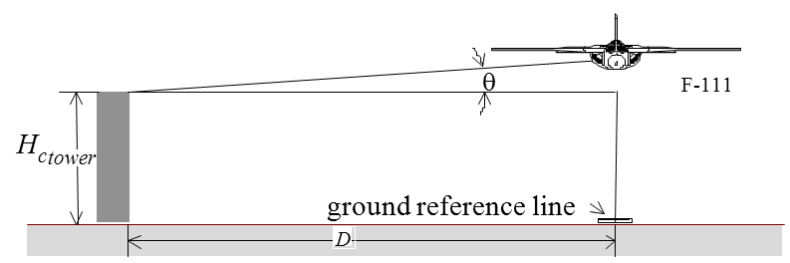

Assumptions

1. No errors in total head.

2. Constant height runs

3. Surveyed course

$$\text{Actual }H_{c}=H_{c_{tower}}+\left(D\tan{θ}⋅\frac{T_{s}}{T_{t}}\right)$$ $ΔH_{pc}=\text{Actual }H_{c}-\left(H_{i}+ΔH_{ic}\right)$

$$ΔP_{S}=-ρgΔH_{pc} \\ ΔP_{S}=q_{c}-q_{cic} \\ ΔP_{S}=1/2ρ_{0}{V_{c}}^{2}-1/2ρ_{0}{V_{ic}}^{2} (\text{low Mach only}) \\ \text{Solve for }V_{c}$$ $ΔV_{pc}=V_{c}-V_{ic}$

See flowchart for high mach or ΔPT≠0 cases.

*Hi* Indicated pressure altitude (29.92” Hg)

Δ *Hic* Instrument error correction

*Hic* Altimeter corrected of instrument error

Δ *Hpc* Position error correction

*Hc* Calibrated pressure altitude